Prizmas pamatlielumi, to aprēķināšana.

Aprēķināt prizmas diagonāli (pamata malu, ja dota prizmas diagonāle), diagonālšķēluma laukumu, augstumu, prizmas sānu virsmas un pilnas virsmas laukumu, prizmas tilpumu.

N.p.k. | Zīmējums | Dots | Risinājums
1. | 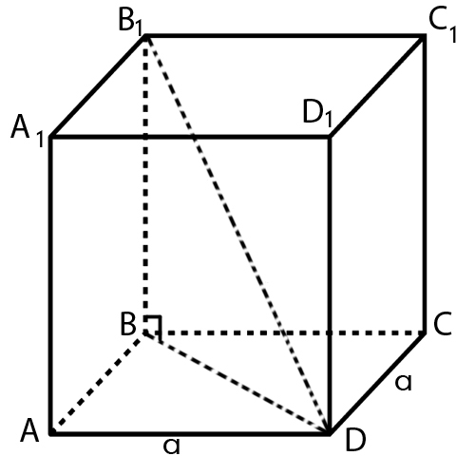 | Kubs, kura mala ir a= 6 cm gara. | $\text{No }Δ\text{ABD}$- taisnleņķa, $\text{BD}=\sqrt{{\text{AB}}^{2}+{\text{BD}}^{2}}=$  $$=\sqrt{6^{2}+6^{2}}=\sqrt{2∗\text{36}}=6\sqrt{2}\text{cm}$$  $$S_{{\text{BB}}_{1}D_{1}D}={\text{BB}}_{1}\text{BD}=6⋅6\sqrt{2}=\text{36}\sqrt{2}\text{cm}$$  $Δ{\text{BB}}_{1}D$- taisnleņķa  $\begin{aligned}B_{1}D=\sqrt{{\text{BB}}_{1^{2}}+{\text{DD}}_{1^{2}}}=\sqrt{2∗6^{2}+6^{2}}=\sqrt{3∗6^{2}=} \\ 6\sqrt{3}\text{cm}\end{aligned}$ S_{pam}$=6^{2}=\text{36}{\text{cm}}^{2}$  S_{sānu}$=P_{\text{pam}\text{.}}⋅H=4∗6∗6=4∗\text{36}=\text{144}{\text{cm}}^{2}$  $S_{\text{pilnaV}}=$S_{sān.}$+2S_{\text{pam}}=4∗\text{36}+2∗\text{36}=6∗6^{2}=\text{216}{\text{cm}}^{2}$  _{V= 6}³= 216cm³
2. | 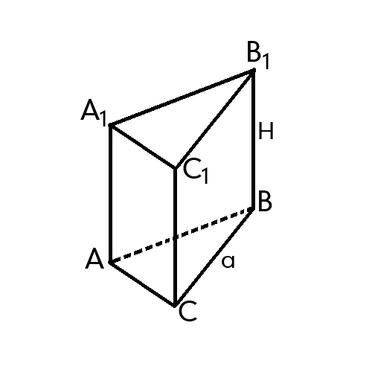 | Regulāra trijstūra  prizma ar pamata malu 4 cm un augstumu 5 cm. | S${}_{\text{pam}}$ = $\frac{4^{2}\sqrt{3}}{4}=4\sqrt{3}{\text{cm}}^{2}$  S_{sānu} = $3a∗H=3∗4∗5=\text{60}{\text{cm}}^{2}$  S_{p.v.}=$\frac{2a^{2}\sqrt{3}}{4}+3\text{aH}=\frac{4^{2}\sqrt{3}}{2}+3∗4∗5=8\sqrt{3}+\text{60}{\text{cm}}^{2}$  V= $\frac{a^{2}\sqrt{3}}{4}∗H=\frac{4^{2}\sqrt{3}}{4}∗5=\text{20}\sqrt{3}{\text{cm}}^{3}$
3. | 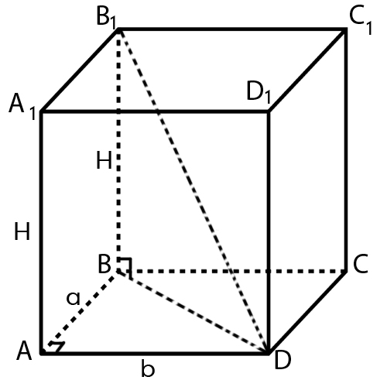 | Taisnstūra paralēlskaldnis  ar dimensijām -  a= 3cm,  b= 4 cm un  H= 5 cm. | No $Δ$ ABD $⇒$ BD = $\sqrt{3^{2}+4^{2}}=\sqrt{\text{25}}=5\text{cm}$  No $Δ$ BB${}_{1}$D $⇒$B${}_{1}$D = $\sqrt{3^{2}+4^{2}+5^{2}}=\sqrt{\text{50}}=5\sqrt{2}\text{cm}$  S${}_{{\text{BB}}_{1}D_{1}D}$ = $\sqrt{3^{2}+4^{2}}⋅5=\text{25}{\text{cm}}^{2}$  S${}_{\text{pam}}$= 3*4=12cm²  S_{sānu}= 2 ($3+4$) $5=\text{70}{\text{cm}}^{2}$  S${}_{p\text{.}v\text{.}}=2\text{ab}+2\left(a+b\right)⋅H=\text{24}+\text{70}=\text{94}{\text{cm}}^{2}$  V= $\text{ab}⋅H=\text{60}{\text{cm}}^{3}$
4. | 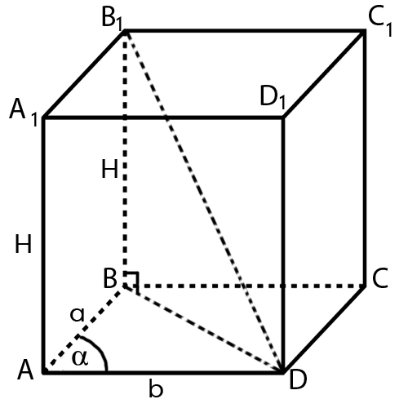 | Taisns paralēlskaldnis, kura pamata malas  a= 3 cm,  b= 4cm veido α= 30⁰ leņķi un augstums H= 5 cm. | No $Δ$ABD  BD = $\sqrt{3^{2}+4^{2}−2∗3∗4\text{cos}{\text{30}}^{0}}=\sqrt{9+\text{16}−\text{12}\sqrt{3}}=\sqrt{\text{25}−\text{12}\sqrt{3}}\text{cm}$  No $Δ{\text{BB}}_{1}D$- taisnleņķa  $B_{1}D=\sqrt{{\text{AD}}^{2}+H^{2}}=\sqrt{\text{25}−\text{12}\sqrt{3}+\text{25}}=\sqrt{\text{50}−\text{12}\sqrt{3}}\text{cm}$$S_{d\text{.}\text{šķ}}=\text{BD}⋅{\text{BB}}_{1}$=*5, jo ${\text{BB}}_{1}D_{1}D$- taisnstūris  $$S_{\text{pam}}=\text{ab}\text{sin}α=3∗4\text{*sin}{\text{30}}^{0}=6{\text{cm}}^{2}$$  S_{sānu} =$2(a+b)∗H=2∗7∗5=\text{70}{\text{cm}}^{2}$  S_{p.v .}=$2\text{ab}\text{sin}α+2(a+b)⋅H=2∗6+\text{70}=\text{82}{\text{cm}}^{2}$  V = $\text{ab}\text{sin}α⋅H=6∗5=\text{30}{\text{cm}}^{3}$
5. | 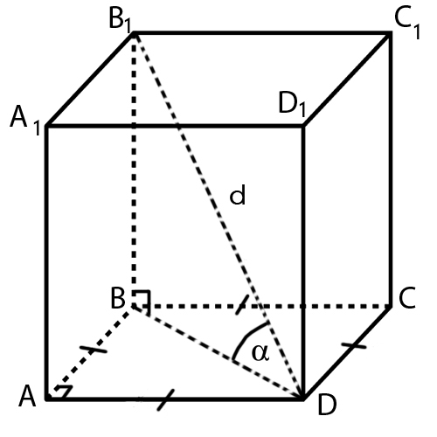 | Kubs, kura diagonāle ir 8 cm gara, ar pamata plakni veido 30⁰ leņķi. | $Δ{\text{BB}}_{1}D$- taisnleņķa  $$\frac{B_{1}B}{d}=\text{sin}α⇒{\text{BB}}_{1}=8\text{sin}{\text{30}}^{0}=4\text{cm}$$  $$\frac{\text{BD}}{d}=\text{cos}α⇒\text{BD}=8\text{cos}{\text{30}}^{0}=4\sqrt{3}\text{cm}$$  S_{d.šk.}=${\text{BB}}_{1}⋅\text{BD}=4∗4\sqrt{3}=\text{16}\sqrt{3}{\text{cm}}^{2}$  Pieņemsim, ka $\text{AD}=a$, no $Δ\text{ABD}$- taisnleņķa  $$\frac{a}{\text{BD}}=\text{cos}\text{45}°⇒a=\frac{4\sqrt{3}∗\sqrt{2}}{2}=2\sqrt{6}\text{cm}$$  S_{pam} = $a^{2}={\left(2\sqrt{6}\right)}^{2}=\text{24}{\text{cm}}^{2}$  S_{sānu} = $4∗\text{24}=\text{96}{\text{cm}}^{2}$  S_{p.v.}= $6∗\text{24}=\text{144}{\text{cm}}^{2}$  V = $\text{24}∗2∗\sqrt{6}=\text{48}\sqrt{6}{\text{cm}}^{3}$

