Prizmas pamatlielumi, to aprēķināšana.

Aprēķināt prizmas diagonāli (pamata malu, ja dota prizmas diagonāle), diagonālšķēluma laukumu, augstumu, prizmas sānu virsmas un pilnas virsmas laukumu, prizmas tilpumu.

N.p.k. | Zīmējums | Dots | Risinājums
1. | 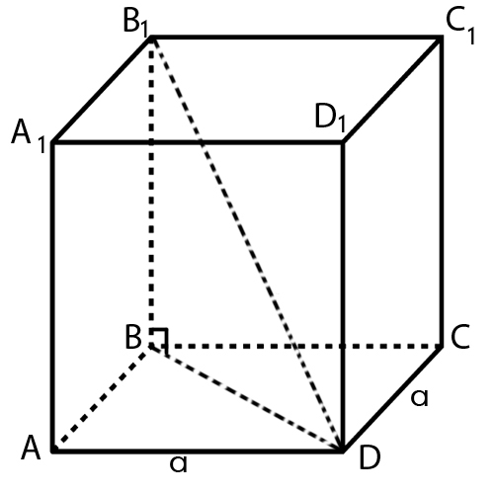 | Kubs ar malu a. | $\text{No }Δ\text{ABD}$- taisnleņķa, $\text{BD}=\sqrt{{\text{AB}}^{2}+{\text{BD}}^{2}}=$  $$=\sqrt{a^{2}+a^{2}}=\sqrt{2a^{2}}=a\sqrt{2}$$  $$S_{{\text{BB}}_{1}D_{1}D}={\text{BB}}_{1}\text{BD}=a⋅a\sqrt{2}=a^{2}\sqrt{2}$$  $Δ{\text{BB}}_{1}D$- taisnleņķa  $\begin{aligned}B_{1}D=\sqrt{{\text{BB}}_{1^{2}}+{\text{DD}}_{1^{2}}}=\sqrt{2a^{2}+a^{2}}=\sqrt{3a^{2}=} \\ a\sqrt{3}\end{aligned}$ S_{pam}$=a^{2}$  S_{sānu}$=P_{\text{pam}\text{.}}⋅H=4a⋅a=4a^{2}$  $S_{\text{pilnaV}}=$S_{sān.}$+2S_{\text{pam}}={\text{Ha}}^{2}+2a^{2}=6a^{2}$  _{V= a}³
2. | 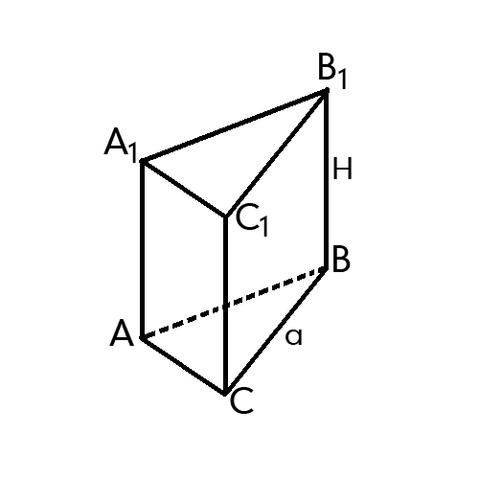 | Regulāra trijstūra  prizma ar pamata malu $a$ un augstumu $H$. | S${}_{\text{pam}}$ = $\frac{a^{2}\sqrt{3}}{4}$  S_{sānu} = $3a⋅H$  S_{p.v.}=$\frac{2a^{2}\sqrt{3}}{4}+3\text{aH}=\frac{a^{2}\sqrt{3}}{2}+3\text{aH}$  V= $\frac{a^{2}\sqrt{3}}{4}H$
3. | 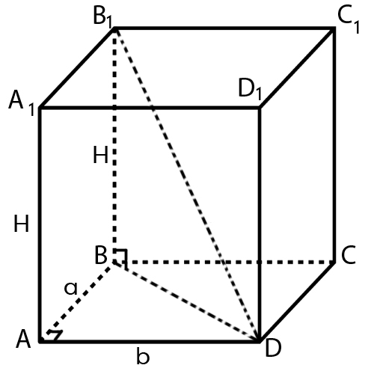 | Taisnstūra paralēlskaldnis  ar dimensijām  $$a,b,H\text{.}$$ | No $Δ$ ABD $⇒$ BD = $\sqrt{a^{2}+b^{2}}$  No $Δ$ BB${}_{1}$D $⇒$B${}_{1}$D = $\sqrt{a^{2}+b^{2}+H^{2}}$  S${}_{{\text{BB}}_{1}D_{1}D}$ = $\sqrt{a^{2}+b^{2}}⋅H$  S${}_{\text{pam}}$= ab  S_{sānu}= 2 ($a+b$) $H$  S${}_{p\text{.}v\text{.}}=2\text{ab}+2\left(a+b\right)⋅H$  V= $\text{ab}⋅H$
4. | 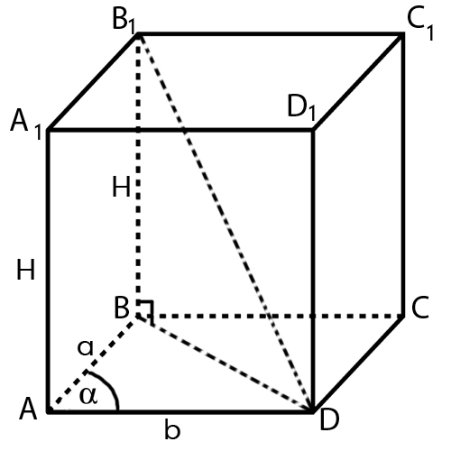 | Taisns paralēlskaldnis, kur pamata malas  $\text{ab}\text{ veido }∠α$ un augstums $H\text{.}$ | No $Δ$ABD  BD = $\sqrt{a^{2}+b^{2}−2\text{ab}\text{cos}α}$  No $Δ{\text{BB}}_{1}D$- taisnleņķa  $B_{1}D=\sqrt{{\text{AD}}^{2}+H^{2}}=\left(\sqrt{a^{2}+b^{2}−2\text{ab}\text{cos}α+H^{2}}\right)$$S_{d\text{.}\text{šķ}}=\text{BD}⋅{\text{BB}}_{1}$, jo ${\text{BB}}_{1}D_{1}D$- taisnstūris  $$S_{\text{pam}}=\text{ab}\text{sin}α$$  S_{sānu} =$2(a+b)⋅H$  S_{p.v .}=$2\text{ab}\text{sin}α+2(a+b)⋅H$  V = $\text{ab}\text{sin}α⋅H$
5. | 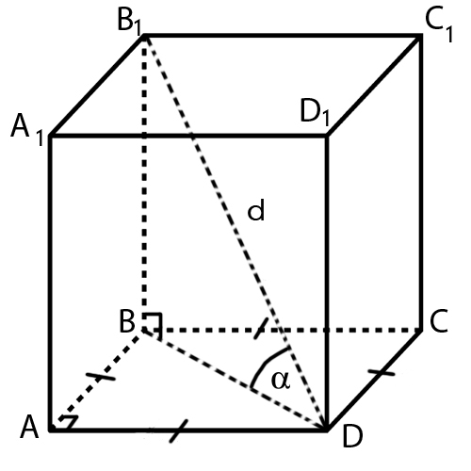 | Kuba diagonāle $d$ ar pamata plakni veido leņķi$α$ | $Δ{\text{BB}}_{1}D$- taisnleņķa  $$\frac{B_{1}B}{d}=\text{sin}α⇒{\text{BB}}_{1}=d\text{sin}α$$  $$\frac{\text{BD}}{d}=\text{cos}α⇒\text{BD}=d\text{cos}α$$  S_{d.šk.}=${\text{BB}}_{1}⋅\text{BD}=d\text{sin}α⋅d\text{cos}α=$  $$=d^{2}\text{sin}α⋅\text{cos}α$$  Pieņemsim, ka $\text{AD}=a$, no $Δ\text{ABD}$- taisnleņķa  $$\frac{a}{\text{BD}}=\text{cos}\text{45}°⇒a=\frac{d\text{cos}α⋅\sqrt{2}}{2}$$  S_{pam} = $\frac{d^{2}{\text{cos}}^{2}α}{2}$  S_{sānu} = $\frac{4⋅d\text{cos}α\sqrt{2}}{2}=2\sqrt{2}d\text{cos}α$  S_{p.v.}= $d^{2}{\text{cos}}^{2}α+2\sqrt{2}d\text{cos}α$  V = $\frac{d^{2}{\text{cos}}^{2}αd\text{sin}α}{2}=\frac{d^{3}{\text{cos}}^{2}α\text{sin}α}{2}$

